**Integrating LLMs for Intelligent Chatbot Support in University Web Platforms**

**ABSTRACT**

Nowadays, artificial intelligence has become an integral part of digital communication, transforming how institutions interact with users. Universities, in particular, are leveraging AI-powered chatbots to improve accessibility, streamline information delivery, and enhance the student experience. In this proposed method, large language models (LLMs) are integrated in order to create an intelligent chatbot for university websites in order to facilitate the services to all the stakeholders of the university in an ease and efficient way. It provides real-time, enquiries regarding admissions, campus resources, and academic support, among other topics. The chatbot is accessible 24/7, reducing the administrative workload by answering routine queries and supporting student engagement. The implementation includes several technical features, such as a user-friendly front end, a secure authentication module, a broadcast system for real-time announcements, and a knowledge base for efficient information retrieval. Additionally, a logging system tracks unhandled queries, enabling continuous improvement by administrators. This chatbot not only automates responses but also personalizes interactions by managing user data, making it an adaptive, scalable solution for academic environments. The approach promises future enhancements in scalability, personalization, and potential multilingual support to meet the growing and diverse needs of the university community.

Keywords: LLM, Chatbot, Authentication, multilingual support, NLP, etc.

1. **INTRODUCTION**

Chatbots, driven by artificial intelligence (AI), have become an integral part of modern digital communication [1]. They are software applications designed to simulate human conversations, providing users with immediate responses to queries and automating various tasks. Through advancements in natural language processing (NLP) and machine learning, chatbots are now capable of understanding and interacting with users in a human-like manner. From answering frequently asked questions to offering personalized recommendations, chatbots have reshaped how we engage with technology across various platforms.

**Chatbots in different domains**

Chatbots have significantly enhanced efficiency, accessibility, and user experience across various sectors. In customer service, they provide instant responses to queries and manage orders 24/7, relieving human agents and boosting customer satisfaction. In healthcare, chatbots facilitate appointment scheduling, symptom checking, and medication information, enabling healthcare providers to focus on critical tasks [2]. In education, they guide students through admissions and offer academic support, ensuring access to essential information and enriching the learning experience [3]. In the banking and finance sector, chatbots manage balance inquiries and transaction histories, allowing users immediate access to account details while handling routine financial tasks autonomously [4]. Lastly, in travel and hospitality, chatbots streamline flight and hotel bookings and provide real-time itinerary updates, simplifying travel planning and enhancing user convenience

**Chatbots for university**

In our project, the integration of an LLM-powered chatbot is crucial for enhancing communication and support within the university [5]. By providing instant, personalized responses to student inquiries, the chatbot facilitates seamless access to essential information, such as course details, admission procedures, and campus resources. This immediate support not only improves student engagement but also alleviates the workload on administrative staff, allowing them to focus on more complex tasks.

Furthermore, the chatbot's ability to operate 24/7 ensures that students can access assistance at any time, catering to diverse schedules and learning preferences. As a result, it fosters a more inclusive environment where all students can receive timely help, enhancing their overall university experience. By leveraging advanced LLM technology, our chatbot aims to deliver intelligent, context-aware interactions that further empower students to navigate their academic journey effectively [6]

**2**.**LITERATURE REVIEW**

The application of AI-driven chatbots has been explored extensively across various domains, demonstrating their potential to enhance communication and streamline processes, while also revealing limitations and challenges.

Chung et al. [7] implemented a chatbot for college websites, integrating various NLP techniques such as keyword extraction, lemmatization, and semantic similarity analysis to improve interaction accuracy. By utilizing Artificial Intelligence Markup Language (AIML), the system was able to deliver contextually relevant responses, thereby reducing the need for manual search efforts. However, the chatbot's reliance on keyword extraction posed challenges, as misidentified keywords could lead to incorrect interpretations of user queries. Despite this limitation, the chatbot significantly enhanced user experiences by providing real-time, automated responses to common inquiries, saving both staff and student’s valuable time.

The study by Untari [8] focused on the use of chatbots in government communications during the COVID-19 pandemic, analyzing real-world chatbots such as COVID19 GO.ID, WHO, and GOV.UK. Through the lens of Media Richness Theory (MRT), the research examined the ability of these chatbots to provide immediate feedback and offer diverse communication cues, including videos and infographics. Comparative analysis between these chatbots revealed key insights for improving Indonesia's own systems. While effective for rapid dissemination of critical information, the case study method limited the ability to generalize findings beyond the pandemic context or the specific chatbots studied.

Chizhik and Zherebtsova [9] explored the development of a retrieval-based chatbot, which selects responses from a pre-existing dataset based on semantic similarity between user input and conversation context. By employing text vectorization techniques like TF-IDF, Word2Vec, and FastText, the chatbot could provide quick and grammatically correct responses. Although retrieval-based chatbots require less training time than generative models, their performance is heavily dependent on the quality of their dataset. The inability to generate novel responses restricts the chatbot’s effectiveness in handling complex or out-of-scope queries, often resulting in repetitive or irrelevant replies.

In the marketing sector, Wagobera Edgar Kedi et al. [10] studied the integration of AI chatbots in small and medium enterprises (SMEs), highlighting their transformative impact on customer interaction and operational efficiency. By leveraging advancements in NLP, machine learning (ML), and data analytics, these chatbots offer personalized experiences, automate routine tasks, and ensure 24/7 customer support. However, challenges such as high initial implementation costs, difficulties in handling complex queries, data privacy concerns, and the need for continuous updates hinder widespread adoption, especially for smaller businesses with limited resources.

Ethical considerations in chatbot use were explored by Nkoulou Mvondo et al. [11], who applied Social Cognitive Theory (SCT) and Rational Choice Theory (RCT) to examine the factors influencing ethical chatbot use among students in the U.S. The study utilized Partial Least Squares Structural Equation Modelling (PLS-SEM) to analyze personal, environmental, and risk-related factors, and employed Fuzzy Set Qualitative Comparative Analysis (fsQCA) to identify conditions leading to ethical or unethical behavior. While the study provided valuable insights into chatbot ethics, the U.S.-centric focus and reliance on self-reported data limited its applicability in broader, global contexts.

Cherednichenko et al. [12] focused on selecting and integrating large language models (LLMs) for chatbot development in Software as a Service (SaaS) platforms. The researchers implemented a system using platforms like Telegram for its robust API and Node.js for handling real-time interactions. ChatGPT was selected for its cost-effectiveness and response speed, while Langchain facilitated the seamless switching between different LLMs. Despite its strengths, the project encountered issues with real-time conversation tracking and the narrow scope of models tested, excluding key competitors like Google’s Gemini.

In education, Zhang and Huang [13] conducted a mixed-methods study to evaluate the use of AI chatbots in enhancing vocabulary acquisition among Mandarin-speaking students learning English. The experimental group using chatbots significantly outperformed the control group, with improved retention rates and engagement. However, the study's focus on written vocabulary limited its insights into speaking skills development, highlighting the need for more comprehensive chatbot systems capable of addressing all aspects of language acquisition.

Modran et al. [14] developed an intelligent tutoring system using Retrieval-Augmented Generation (RAG), combining retrieval-based and generative approaches to provide personalized responses in educational contexts. Indexed educational materials were retrieved via LlamaIndex, while machine learning was used to adapt responses to individual learning styles. Though effective in providing contextually accurate tutoring and quizzes, the system's reliance on high-quality content posed a challenge, especially when dealing with incomplete or outdated data. Early testing demonstrated promise, but further development and testing are required to expand the system’s subject coverage.

Lajčinová et al. [15] examined the use of large language models (LLMs) like BERT for intent classification in the banking sector. By fine-tuning SlovakBERT with user query datasets, they achieved significant accuracy improvements, outperforming general-purpose multilingual models like Gemma 7b and Llama 8b. The study underscored the importance of localized models for specific industries, but also highlighted the challenges of data translation and the limited scalability of fine-tuned models compared to their zero-shot learning counterparts.

Yigci et al. [16] explored the integration of LLM-based chatbots in higher education, particularly their role in personalized learning and curriculum development. While these chatbots provided efficient support in tasks like coding and subject-specific tutoring, concerns regarding academic integrity and potential over-reliance on AI raised significant ethical questions. The study recommended the cautious integration of AI tools to ensure they enhance, rather than hinder, critical thinking and learning autonomy.

Giudici et al. [17] developed GreenIFTTT, an automation tool using GPT-4 to promote sustainable energy consumption through smart home routines. An exploratory study with users demonstrated the system's ease of use and engagement, but slower response times due to the LLM integration and reliance on accurate AI outputs were noted as potential areas for improvement. The system, while promoting sustainability, had limited testing in real-world environments, which could affect its performance when deployed on a larger scale.

In healthcare, Athota et al. [18] investigated the integration of LLMs like ChatGPT and Med-PaLM 2 into clinical workflows. These models were shown to reduce the administrative burden on healthcare providers by automating tasks such as patient documentation and appointment scheduling. However, concerns regarding patient data privacy, the accuracy of AI-generated diagnostic information, and the potential for over-reliance on these tools in critical situations raised important ethical and practical considerations for the future of AI in healthcare.

Finally, Xue et al. [19] examined the ethical challenges posed by chatbot biases, which stem from training data, developer backgrounds, and user interactions. These biases can propagate harmful stereotypes or offensive content, particularly in industries like customer service. The study recommended the use of fairness toolkits and diverse development teams to mitigate bias.

Cortés-Cediel et al. [20] conducted a systematic review on e-government chatbots, providing a comprehensive overview of their deployment in public administration. However, the study’s context-specific nature, focusing primarily on Spanish public administration, limited its applicability to other regions, and it did not fully account for emerging trends in chatbot technology.

**3.METHODOLOGY**

The development of the university chatbot website required a structured approach to ensure efficient query handling, seamless user interaction, and continuous system improvement. This methodology outlines the key technologies and strategies used, along with the rationale for their selection.

**A. Chatbot Framework: Botpress**

The Botpress framework was chosen to build the core chatbot functionalities due to its modular, flexible, and open-source nature. It provides a comprehensive set of tools for developing conversational agents and integrates well with various platforms and technologies.

* **Modularity**:

Botpress offers a modular architecture, making it easy to add or update specific functionalities, such as the broadcast module, authentication, and knowledge management systems. The modular design ensures that the system can be expanded and maintained easily as new requirements arise.

* **Natural Language Processing (NLP)**:

Botpress includes built-in NLP capabilities, which help interpret and respond to user queries. Its ability to handle both structured and unstructured queries makes it ideal for managing typical university-related inquiries like admissions, campus directions, and event details.

* **Ease of Integration**:

Botpress integrates seamlessly with web technologies, allowing the chatbot to be easily embedded into the website and interact with the frontend and backend systems. Its graphical interface also simplifies the management of conversational flows and the knowledge base.

**B. Integration of Large Language Model (LLM)**

To address more complex and open-ended queries, we integrated a Large Language Model (LLM) into the chatbot. The LLM was selected to complement Botpress by handling queries that required deeper contextual understanding and more advanced language processing.

* **Advanced NLP**:

While Botpress handles structured queries well, an LLM can understand and respond to more sophisticated questions that go beyond predefined patterns. This allows the chatbot to engage in more fluid and flexible conversations, providing a more natural interaction for users.

* **Contextual Understanding**:

LLMs excel at understanding the context of a conversation, which is critical for a university chatbot where users might ask a wide variety of questions. By integrating the LLM, we ensure that the chatbot can handle queries like "How can I apply for a scholarship?" or "Can you suggest good study spots on campus?" with rich, context-aware responses.

* **Continuous Learning**:

The LLM can be fine-tuned over time with additional data, allowing it to improve its accuracy and relevance when answering university-specific queries. This aligns with the overall goal of making the chatbot more adaptive to the diverse needs of students and faculty.

**C. User Authentication System**

To personalize the chatbot experience and ensure secure interactions, a user authenticationsystem was implemented. This system requires users to provide their name and phonenumber before accessing the chatbot’s services.

* **Data Security**:

By authenticating users, we ensure that user data is securely stored and managed. This approach also allows the system to provide personalized responses (e.g., greeting users by name) and ensures that user-specific interactions (like session data) are maintained.

* **Session Management**:

Authentication also helps track user sessions, ensuring that users have a consistent experience across different interactions with the chatbot. This helps maintain the context of the conversation and enables features such as personalized recommendations or follow-ups.

**D. Broadcast Module**

The **Broadcast Module** was implemented to allow administrators to post **real-time announcements** that are displayed on the chatbot webpage. This feature was included to enhance communication between the university and its users.

* **Real-Time Updates**:

The decision to include a broadcast module was based on the need for real-time dissemination of important university information, such as event updates or critical notifications. The module ensures that users are always informed of the latest news, displayed dynamically as a ticker on the chatbot interface.

* **Admin Control**:

The broadcast module was designed with an easy-to-use admin interface, allowing non-technical users (e.g., university staff) to update announcements without needing to modify the core chatbot code. This helps ensure timely and accurate communication with students and staff.

**E. Knowledge Base and Log Management**

The chatbot relies on a knowledge base to provide answers to frequently asked questions, while a log management system tracks and stores queries that the chatbot cannot handle.

* **Botpress Knowledge Base**:

Botpress’s content management system allows administrators to manage predefined responses for common queries, such as questions related to admissions, campus events, or directions. The structured knowledge base ensures that frequently asked questions are answered quickly and accurately.

* **Log System for Continuous Improvement**:

A logging system was introduced to capture unhandled queries, which the chatbot could not answer. This log is reviewed by administrators who update the knowledge base with appropriate responses, allowing the system to continuously improve and adapt to new user needs.

**F. Backend and Database Design**

The backend infrastructure was designed to handle data storage, processing, and user management. A database was integrated to store user information, chatbot logs, and announcements.

* **Database Selection**:

A relational database was selected to store user authentication data (name, phone number), chatbot logs, and admin-generated content (such as announcements). This ensures data consistency and secure storage.

* **Scalability**:

The backend system was designed with scalability in mind, ensuring that as the number of users grows, the system can handle increased traffic and queries without compromising performance.

**Summary of Methodological Approach**

The choice of technologies in this project was guided by the need for a flexible, scalable, and user-friendly system. Botpress was selected for its modularity and ease of use, while the LLM integration

provides advanced capabilities for handling complex queries. The user authentication system and broadcast module enhance personalization and communication, and the log management system ensures that the chatbot can continuously learn and improve

1. **IMPLEMENTATION**

The chatbot for the university website aims to simplify access to key university services and improve the user experience. Built using Botpress and powered by a Large Language Model (LLM), the chatbot provides automated assistance to students, faculty, and visitors. It handles a wide range of tasks, including answering common queries, providing directions using a university map, and broadcasting important announcements.

**A. Frontend Development**

The frontend of the chatbot website is developed using HTML, CSS, and JavaScript, ensuring a responsive and dynamic user interface:

* HTML structures the web pages.
* CSS ensures the aesthetic and branding consistency of the site.
* JavaScript enables interactive elements, such as form validation and real-time chatbot responses.

The chatbot widget is embedded into the website and uses JavaScript to facilitate real-time communication between the user interface and the chatbot engine.

**B. Chatbot Development Using Botpress and LLM**

The core chatbot functionalities were developed using Botpress integrated with a Large Language Model (LLM) for enhanced natural language understanding and responses.

1. BOTPRESS FOR STRUCTURED CONVERSATIONS:

Botpres**s** handles frequently asked questions (FAQs) and structured queries related to the university, such as admissions, directions, and event details. It leverages predefined intents and decision trees for handling standard user requests.

The chatbot is trained with a university map to provide campus directions. When a user asks, “Where is the administration building?”, the chatbot consults the map and provides accurate directions.

1. LLM INTEGRATION FOR COMPLEX QUERIES:

For more complex, open-ended queries, the chatbot is integrated with an LLM. This model allows the chatbot to provide more nuanced, context-aware responses that go beyond simple FAQ patterns.

The LLM enhances the chatbot's ability to handle diverse natural language inputs, offering flexible and intelligent responses. For instance, when users ask questions like, "What are the steps to apply for financial aid?" or "Can you suggest some good study spots on campus?", the LLM interprets the query and provides relevant, context-rich answers.

1. HANDLING UNKNOWN QUERIES:

Queries that cannot be handled by predefined responses or the LLM are logged for further analysis and improvements to the knowledge base. This ensures that the chatbot continuously improves over time.

C. USER AUTHENTICATION MODULE

To ensure personalized user interactions, the chatbot requires users to authenticate themselves:

Users provide their name and phone number for authentication.

The JavaScript-based frontend validation ensures the correct format of input, and the data is securely stored in the backend database.

Once authenticated, user sessions are managed, allowing the chatbot to greet users by name and provide a personalized experience.

D. Knowledge Base and Log Management

1. Knowledge Base:

The chatbot has a dual knowledge system: a structured knowledge base managed in Botpress and the dynamic capabilities of the LLM.

The structured knowledge base covers frequently asked queries about admissions, campus navigation, and event details. The knowledge base is managed using Botpress’s content management system, allowing easy updates by administrators.

1. Log File System:

A log file system tracks queries that cannot be answered by either the Botpress knowledge base or the LLM. These unhandled queries are reviewed by administrators, who can update the chatbot’s knowledge base with appropriate responses.

This feedback loop ensures the chatbot continuously evolves and improves, becoming more robust over time.

E. Broadcast Module

A Broadcast Module allows administrators to send important announcements to users:

Admin Functionality: Admins can post announcements through a dedicated panel. These messages appear as a scrolling ticker at the bottom of the webpage, providing real-time updates to all users.

Dynamic Updates: The broadcast ticker is automatically updated whenever a new message is posted, ensuring timely information dissemination.

F. Backend Infrastructure

Database: The backend uses a database to store user data (names, phone numbers) and chatbot logs. This database ensures persistent storage of user sessions and enables personalized chatbot interactions.

Server: The chatbot is hosted on a server that processes user queries, handles communication with the Botpress engine, the LLM, and manages database operations.

G. Map-Based Directions

One of the chatbot’s standout features is its ability to provide directions within the university campus:

The chatbot is trained with a digital map of the university, which is integrated into its knowledge base. When users ask for directions, the chatbot retrieves map coordinates and provides step-by-step instructions to the desired location.

This feature is particularly useful for new students and visitors navigating the campus.

H. Continuous Learning and Improvement

The chatbot system is designed for continuous improvement:

LLM Updates: The LLM’s ability to handle complex and open-ended queries allows for flexible learning. As new types of queries are encountered, the LLM adapts and improves its responses.

Admin Feedback Loop: Administrators review the log files of unhandled queries, and these are used to expand the knowledge base in Botpress, ensuring the chatbot stays up-to-date with current user needs.

**Technical Workflow**

1. User Authentication: Users provide their name and phone number → JavaScript validates the input → User session is created and personalized.
2. Query Handling:

Simple queries: Processed by Botpress, returning responses from a structured knowledge base.

Complex queries: Routed to the LLM for more intelligent, context-aware responses.

Unhandled queries: Logged for admin review and future system updates.

1. Broadcast Module: Admin posts an announcement → Broadcast ticker updated in real-time at the bottom of the webpage.
2. Log Management: Logs of unanswered queries are reviewed and the knowledge base is updated according

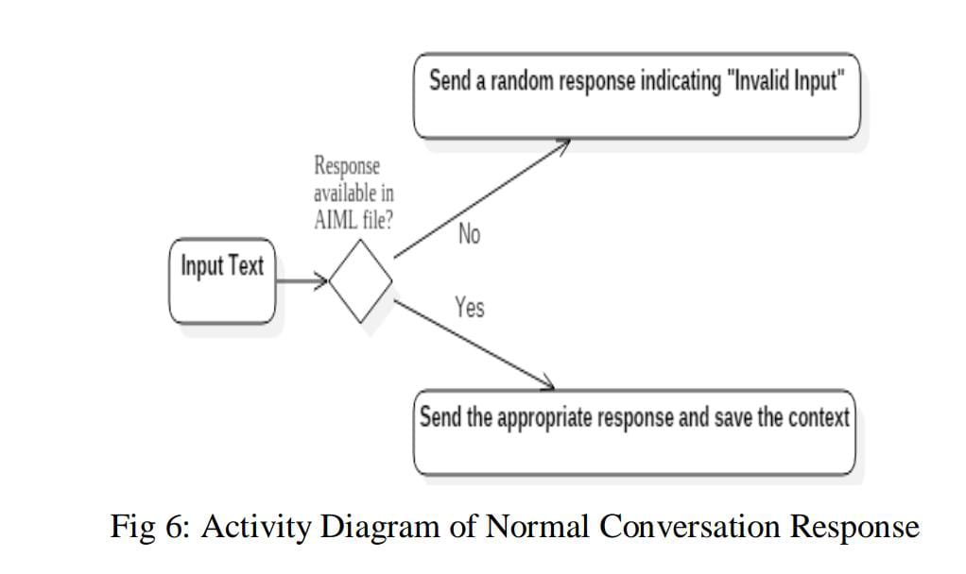

FIg1: Activity Diagram of Normal Conversation Response

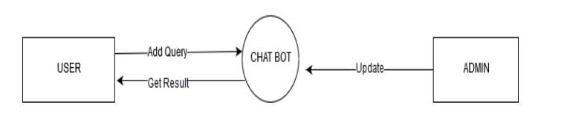

Fig2: Chatbot training and Updating by Admin

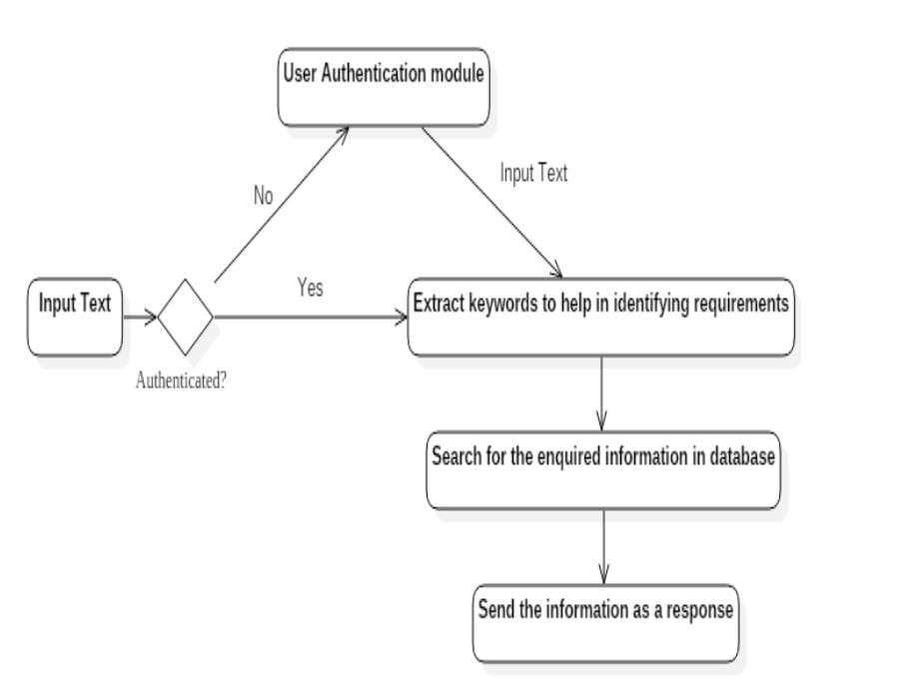

Fig 3: Activity Diagram of Personal Query Response Activity

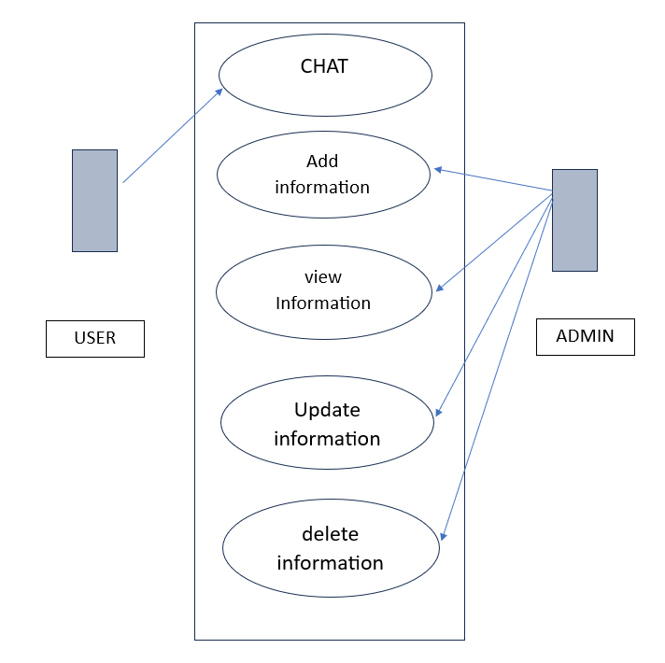

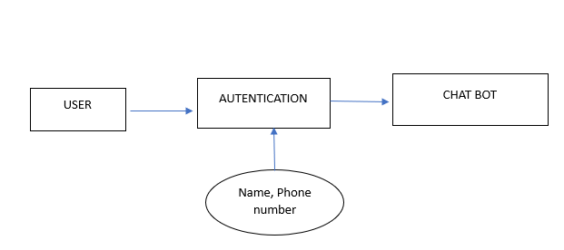

Fig4: User Authentication

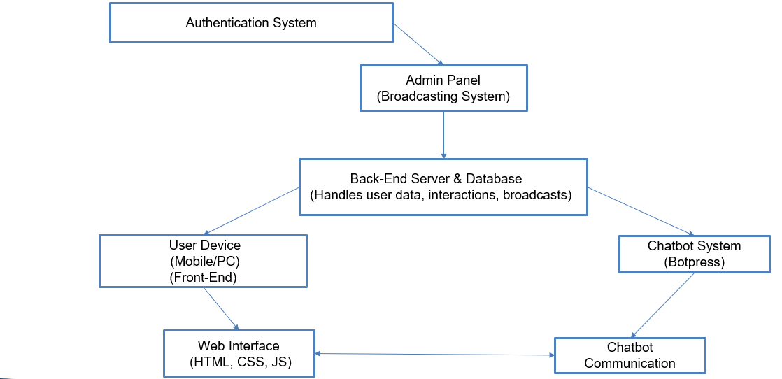

Fig5: Workflow

**5.RESULTS AND DISCUSSION**

The development and implementation of a university chatbot using Botpress and a Large Language Model (LLM) demonstrate the significant benefits of modular, scalable, and adaptive systems in addressing diverse user needs. This discussion reflects on the key aspects of the methodology, evaluating the success of the approach and identifying areas for future improvement.

1. Effectiveness of the Chatbot Framework (Botpress)

Botpress proved to be a strong choice for building the chatbot's core functionality, mainly due to its modular architecture. The ability to add or update specific functionalities, such as the broadcast module and authentication system, has simplified system management and allowed for rapid iterations. The modularity ensures that the system is adaptable to changing requirements, an essential feature given the dynamic nature of university environments.

The Natural Language Processing (NLP) capabilities of Botpress effectively handle structured queries, such as frequently asked questions related to admissions, schedules, and campus events. However, the framework’s reliance on predefined conversational flows limits its ability to handle more complex, open-ended questions. This shortcoming was addressed by the integration of an LLM, which brings us to the next point of discussion.

2. The Role of LLM in Enhancing User Interaction

The integration of an LLM significantly improved the chatbot's ability to handle complex and context-sensitive queries. The LLM's advanced NLP capabilities allowed the system to go beyond predefined conversational patterns, providing users with more natural and fluid interactions. This integration added a layer of sophistication to the chatbot, allowing it to understand and respond to queries that require deeper context, such as "How do I apply for a scholarship?" or "What are some study recommendations for my major?"

However, while the LLM enhances user experience, it also introduces challenges. The primary concern is the system's dependency on external data sources, which might lead to occasional inaccuracies or responses that do not align perfectly with the university's specific guidelines or policies. Continuous monitoring and fine-tuning of the LLM, combined with frequent updates to the knowledge base, are necessary to ensure that the responses remain accurate and relevant.

3. Security and Personalization Through User Authentication

The decision to implement a user authentication system contributed to both the security and personalization of the chatbot service. By collecting basic user data (name, phone number), the system ensures that only authenticated users can access the chatbot's personalized features. The addition of session management also ensures that user interactions are consistent and continuous, enhancing the overall user experience.

However, data security is an area that requires ongoing vigilance. Ensuring that user data is handled according to strict privacy standards, such as the General Data Protection Regulation (GDPR), is critical for maintaining trust, especially in environments like universities, where large volumes of sensitive data are processed.

4. Real-Time Communication with the Broadcast Module

The inclusion of a broadcast module in the chatbot was a strategic decision, allowing the university to push real-time announcements to users. This feature ensures that users are informed about important events or urgent notifications, such as class cancellations or campus safety updates. The ease of use provided by the admin panel enables non-technical university staff to manage announcements effectively.

One limitation of the current broadcast system is that it primarily serves a one-way communication function. Future iterations could consider making the broadcast system more interactive, where users can respond to announcements, ask for more details, or request personalized updates based on their preferences.

5. Continuous Improvement Through Log Management

A key strength of the project is the log management system, which records unhandled queries. This feature ensures that the chatbot can continuously evolve by updating the knowledge base based on real user interactions. By tracking these logs, administrators can refine the chatbot's responses and incorporate new information, thereby enhancing the system’s long-term adaptability.

The challenge here lies in managing the volume of logs. As the system scales and the number of users grows, manually reviewing logs and updating the knowledge base could become time-consuming. Automating parts of this process, such as categorizing unhandled queries or prioritizing them based on frequency, would be beneficial.

6. Scalability and Future Considerations

The backend and database design, focusing on scalability, ensures that the system can handle an increasing number of users without compromising performance. The use of a relational database allows for secure storage of user data, chatbot logs, and admin-generated content. As the university grows, the system’s ability to handle higher traffic and more complex queries will be tested. Ensuring the database and server infrastructure can handle this expansion is a priority.

Future developments could also explore additional features like Wi-Fi detection for location-based services, which could further improve campus navigation and user personalization. Additionally, incorporating multilingual support could be valuable for universities with diverse student populations.

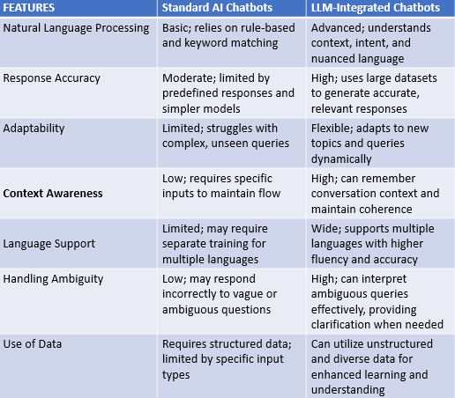

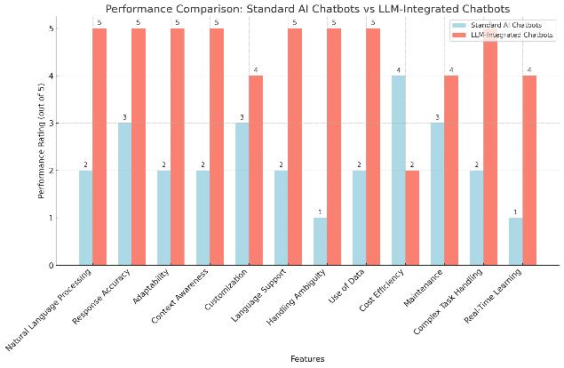

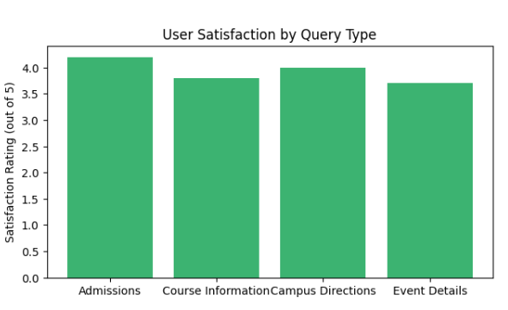

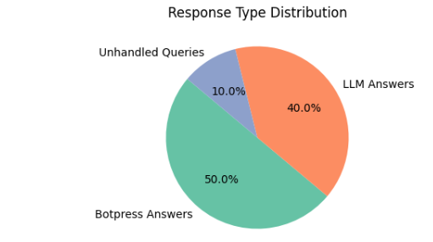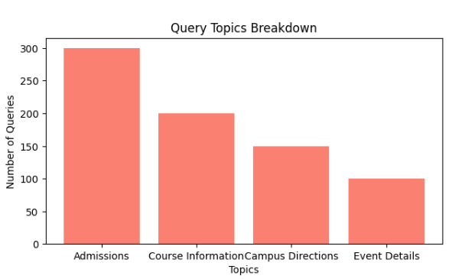

**CONCLUSION:**

The university chatbot developed using Botpress, with LLM integration and modular components like user authentication and broadcast systems, has created a flexible, secure, and scalable solution. The methodology ensures that the chatbot meets immediate user needs while remaining adaptable for future improvements. However, continuous monitoring, refinement, and scalability considerations will be essential as the system evolves to accommodate more complex user requirements and larger user bases.

Despite the system's overall success, opportunities for improvement remain. Future development should focus on refining the chatbot’s response accuracy, automating log analysis, and expanding interactive features within the broadcast system. Furthermore, ensuring scalability to accommodate growing user demands and integrating advanced technologies such as location-based services will solidify the chatbot’s role as an essential tool for enhancing the university's digital infrastructure.

In conclusion, this project demonstrates the potential of combining modular frameworks like Botpress with cutting-edge language models to create a dynamic, user-centric chatbot that meets the evolving needs of a university environment. By continuously iterating and improving on this foundation, the system can continue to provide value to students, faculty, and administrators alike.

**REFERENCES:**

[1] A. Mondal, M. Dey, D. Das, S. Nagpal and K. Garda, "Chatbot: An automated conversation system for the educational domain," 2018 International Joint Symposium on Artificial Intelligence and Natural Language Processing (iSAI-NLP), Pattaya, Thailand, 2018.

[2] S. Montagna et al., "LLM-based Solutions for Healthcare Chatbots: A Comparative Analysis," 2024 IEEE International Conference on Pervasive Computing and Communications Workshops and other Affiliated Events (PerCom Workshops), Biarritz, France, 2024.

[3] A. Kiran, I. J. Kumar, P. Vijayakarthik, S. K. L. Naik and T. Vinod, "Intelligent Chat Bots: An AI Based Chat Bot for Better Banking Applications," 2023 International Conference on Computer Communication and Informatics (ICCCI), Coimbatore, India, 2023.

[4] B. R. Ranoliya, N. Raghuwanshi and S. Singh, "Chatbot for university related FAQs," 2017 International Conference on Advances in Computing, Communications and Informatics (ICACCI), Udupi, India, 2017.

[5] M. Dean, R. R. Bond, M. F. McTear and M. D. Mulvenna, "ChatPapers: An AI Chatbot for Interacting with Academic Research," 2023

[6] S. Vakayil, D. S. Juliet, A. J and S. Vakayil, "RAG-Based LLM Chatbot Using Llama-2," 2024 7th International Conference on Devices, Circuits and Systems (ICDCS), Coimbatore, India, 2024

[7] Lalwani, Tarun, et al. "Implementation of a Chatbot System using AI and NLP." *International Journal of Innovative Research in Computer Science & Technology* 6.3 (2018): 26-30.

[8] Untari IM. Chatbots and government communications in Covid-19 Pandemic. Jurnal Komunikasi Indonesia, IX. 2020 Dec .

[9] Chizhik, Anna, and Yulia Zherebtsova. "Challenges of Building an Intelligent Chatbot." In *IMS*, pp. 277-287. 2020.

[10] Wagobera Edgar, Kedi, Chibundom Ejimuda, Courage Idemudia, and Tochukwu Ignatius Ijomah. "AI Chatbot integration in SME marketing platforms: Improving customer interaction and service efficiency." *International Journal of Management & Entrepreneurship Research* 6, no. 7 (2024).

[11] Mvondo, Gustave Florentin Nkoulou, Ben Niu, and Salman Eivazinezhad. "Exploring The Ethical Use of LLM Chatbots In Higher Education." *Available at SSRN4548263 (2023)* (2023).

[12] Cherednichenko, Olga & Sytnikov, Dmytro & Romankiv, Nazarii & Sharonova, Nataliia & Sytnikova, Polina. (2024). Selection of large language model for development of interactive chat bot for SaaS solutions.

[13] Zhang, Zhihui, and Xiaomeng Huang. "The impact of chatbots based on large language models on second language vocabulary acquisition." *Heliyon* 10, no. 3 (2024).

[14] Modran, Horia, et al. "LLM intelligent agent tutoring in higher education courses using a RAG approach." (2024).

[15] Lajčinová, Bibiána, Patrik Valábek, and Michal Spišiak. "Intent Classification for Bank Chatbots through LLM Fine-Tuning." *arXiv preprint arXiv:2410.04925* (2024).

[16] Yigci, Defne, Merve Eryilmaz, Ail K. Yetisen, Savas Tasoglu, and Aydogan Ozcan. "Large Language Model‐Based Chatbots in Higher Education." *Advanced Intelligent Systems* (2024).

[17] Giudici, Mathyas, et al. "Designing Home Automation Routines Using an LLM-Based Chatbot." *Designs* 8.3 (2024).

[18] Athota, Lekha, Vinod Kumar Shukla, Nitin Pandey, and Ajay Rana. "Chatbot for healthcare system using artificial intelligence." 2020.

[19] Xue, Jintang, Yun-Cheng Wang, Chengwei Wei, Xiaofeng Liu, Jonghye Woo, and C-C. Jay Kuo. "Bias and fairness in chatbots: An overview." *arXiv preprint arXiv:2309.08836* (2023).

[20] Cortés-Cediel, María E., et al. "Trends and challenges of e-government chatbots: Advances in exploring open government data and citizen participation content." *Government Information Quarterly* 40.4 (2023).